Spark Training questions
Please answer the questions below

Exercise 1
Q1. Please put your code here:

import sys
from pyspark import SparkContext, SparkConf

if __name__ == "__main__":
if len(sys.argv) != 2:
print("Usage: wordcount <input_folder>", file=sys.stderr)
sys.exit(-1)

conf = SparkConf().setAppName("python-word-count")
sc = SparkContext(conf=conf)

text_file = sc.textFile("hdfs://" + sys.argv[1])
counts = text_file.flatMap(lambda line: line.split(" ")) \
.map(lambda word: (word, 1)) \
.reduceByKey(lambda a, b: a + b) \
.repartition(5) \
.filter(lambda x: len(x[0])>5)
# "takeOrdered" is an action.
list = counts.takeOrdered(40, key = lambda x: -x[1])
print("--------------------------------------------")
# print (repr(list)[1:-1])
print(*list, sep="\n")
print("--------------------------------------------")

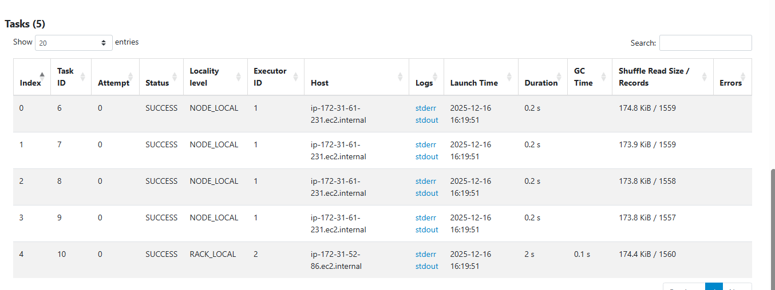
Q2. Add print-screen of the stage proving you have 5 tasks

Exercise 2
Q1. Please put your code here:

import sys
from pyspark import SparkContext, SparkConf

if __name__ == "__main__":
if len(sys.argv) != 2:
print("Usage: wordcount <input_folder>", file=sys.stderr)
sys.exit(-1)

conf = SparkConf().setAppName("python-word-count")
sc = SparkContext(conf=conf)

text_file = sc.textFile("hdfs://" + sys.argv[1])

raw_words = text_file.flatMap(lambda line: line.split(" ")).cache()
distinct_words_count = raw_words.distinct().count()

counts = raw_words.map(lambda word: (word, 1)) \
.reduceByKey(lambda a, b: a + b) \
.repartition(5) \
.filter(lambda x: len(x[0]) > 5)

list = counts.takeOrdered(40, key=lambda x: -x[1])

print("--------------------------------------------")
print(*list, sep="\n")
print("--------------------------------------------")
print("Total distinct words (all words):", distinct_words_count)

Q2. Write the number of words found

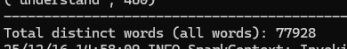

Exercise 3
Put a print-scrin with the DAG of the first stage, which shows it reads the files from s3a://<your_bucket_name>

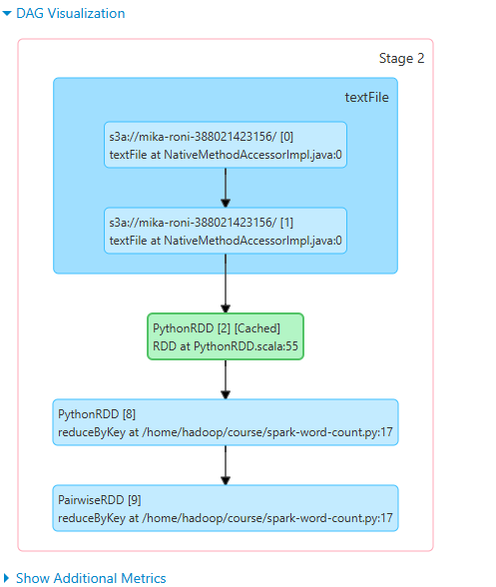

Exercise 4
Q1. Please put your code here:

import sys
from pyspark import SparkContext, SparkConf

if __name__ == "__main__":
if len(sys.argv) != 2:
print("Usage: wordcount <input_folder>", file=sys.stderr)
sys.exit(-1)

conf = SparkConf().setAppName("python-word-count")
sc = SparkContext(conf=conf)

text_file = sc.textFile("s3a://" + sys.argv[1])

words = text_file.flatMap(lambda line: line.split(" ")) \
.map(lambda w: w.rstrip('.,')) \
.filter(lambda w: w.isalpha())

longest_word = words.reduce(lambda w1, w2: w1 if len(w1) >= len(w2) else w2)

print("--------------------------------------------")
print("Longest word:", longest_word)
print("Length:", len(longest_word))
print("--------------------------------------------")

Q2. Put here the printout of the longest word:

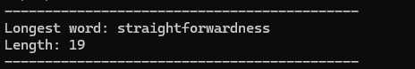

Exercise 5
Q1. Please put your code here:

import sys
from pyspark import SparkContext, SparkConf

def count_words_in_line(text_file):
lines_with_counts = text_file.map(lambda line: (line, len(line.split(" "))))

max_line = lines_with_counts.reduce(lambda l1, l2: l1 if l1[1] >= l2[1] else l2)

return max_line

if __name__ == "__main__":
if len(sys.argv) != 2:
print("Usage: count_words_in_line <s3_path>", file=sys.stderr)
sys.exit(-1)

conf = SparkConf().setAppName("count-words-in-line")
sc = SparkContext(conf=conf)

text_file = sc.textFile("s3a://" + sys.argv[1])

max_line = count_words_in_line(text_file)

print("--------------------------------------------")
print("Line with the most words:")
print(max_line[0])
print("Number of words:", max_line[1])
print("--------------------------------------------")

Q2. Put here the printout of the line with the most words:
